

Group members

Khuzaim Adnan

Mohammad Shabbir

Javeria Noor

# BookMyDoc Application Documentation

## Abstract

BookMyDoc is a Flutter-based digital healthcare platform designed to streamline medical appointment scheduling, enhance doctor-patient communication, and integrate advanced AI capabilities for improved healthcare delivery. The application bridges the gap between doctors and patients by offering an intuitive interface for booking appointments, managing doctor availability, accessing prescriptions, and leveraging AI-driven features like symptom analysis and personalized health recommendations. By reducing the need for in-person scheduling visits and incorporating real-time chat and AI assistance, BookMyDoc enhances efficiency and accessibility in healthcare services.

## 1. Introduction

The growing demand for accessible and efficient healthcare solutions has driven the development of platforms like BookMyDoc. This application addresses the inefficiencies of traditional appointment systems by providing real-time scheduling, secure communication, and AI-powered tools to support both patients and doctors. Built using Flutter for cross-platform compatibility and Firebase for robust backend services, BookMyDoc offers a seamless experience for managing medical consultations in Pakistan and beyond.

## 2. Problem Statement

Traditional healthcare appointment systems in Pakistan often involve manual processes, long waiting times, and limited access to real-time doctor availability. Patients face challenges such as scheduling conflicts, lack of immediate communication with doctors, and difficulty accessing prescriptions or medical advice remotely. Additionally, doctors struggle to manage their schedules efficiently and communicate effectively with patients outside of physical consultations. The absence of integrated AI tools further limits the ability to provide quick symptom analysis or personalized health insights, particularly in underserved areas. BookMyDoc aims to address these issues by offering a digital platform that simplifies appointment booking, enhances communication, and leverages AI to improve healthcare accessibility and efficiency.

## 3. Objectives

* **Streamline Appointment Booking**: Enable patients to book appointments with available doctors using an intuitive calendar-based system.
* **Facilitate Doctor Schedule Management**: Provide doctors with tools to dynamically set and update their availability for efficient time management.
* **Enhance Doctor-Patient Interaction**: Improve accessibility to medical services, prescriptions, and real-time communication through chat and AI-driven tools.
* **Integrate AI Capabilities**: Incorporate AI for symptom analysis, personalized health recommendations, and improved patient support.
* **Improve Healthcare Accessibility**: Reduce delays, scheduling conflicts, and barriers to accessing medical consultations, particularly in Pakistan's healthcare landscape.

## 4. Background Study (Similar Applications)

To contextualize BookMyDoc, a background study was conducted to analyze similar healthcare applications, particularly those operating in Pakistan. Below are some notable examples:

* **Marham** (Pakistan): A leading healthcare platform in Pakistan that connects patients with doctors for consultations and appointments. It offers online booking and doctor reviews but lacks advanced AI integration for symptom analysis or personalized recommendations.
* **Oladoc** (Pakistan): A digital health platform providing appointment booking, teleconsultations, and health records management. While user-friendly, it does not emphasize real-time chat or AI-driven diagnostics.
* **Sehat Kahani** (Pakistan): Focuses on telemedicine, connecting patients with doctors via video consultations. It serves underserved communities but lacks robust AI features and comprehensive scheduling tools.
* **Practo** (India, with some presence in Pakistan): A widely used platform for booking appointments and accessing teleconsultations. It includes basic symptom checkers but does not offer advanced AI-driven insights tailored to local needs.
* **DoctorOnCall** (Regional): A telemedicine platform offering virtual consultations. It focuses on video-based interactions but lacks integrated AI for proactive health management.

**BookMyDoc Differentiation**: Unlike these platforms, BookMyDoc integrates AI-driven features, such as symptom analysis and personalized health recommendations, alongside real-time chat and a robust scheduling system. This makes it particularly suited for Pakistan's diverse healthcare needs, combining accessibility with advanced technology.

## 5. Research Method

The development of BookMyDoc followed the System Development Life Cycle (SDLC) methodology, ensuring a structured approach to building a robust application. The phases included:

1. **Requirements Definition**: Gathered user requirements through surveys and interviews with doctors and patients to identify key features, such as AI-driven symptom analysis, real-time chat, and appointment management.
2. **System and Software Design**: Designed the application architecture using Flutter for the frontend, Firebase for backend services, and Provider for state management. AI integration was planned using APIs for symptom analysis and recommendation systems.
3. **Implementation and Unit Testing**: Developed the frontend with Flutter, integrated Firebase for authentication, database, and chat, and incorporated AI APIs for health-related features. Unit testing was conducted for individual components.
4. **Integration and System Testing**: Combined all components, including Google Sign-In, Table Calendar, and AI modules, into a cohesive system. System-wide testing ensured functionality and reliability.
5. **Operation and Maintenance**: Deployed the application on Android (with plans for iOS) and established a maintenance plan for regular updates, including AI model enhancements and bug fixes.

## 6. Technologies Used

* **Flutter (Frontend)**: Used for building a responsive, cross-platform user interface compatible with Android and iOS.
* **Firebase (Backend)**: Provides authentication, real-time database, cloud functions, and messaging for seamless backend operations.
* **Provider (State Management)**: Manages application state efficiently across multiple screens.
* **Navigator (Screen Navigation)**: Ensures smooth transitions between application screens.
* **Image and File Picker**: Allows users to upload profile images or medical documents.
* **Google Fonts**: Enhances visual appeal with customizable typography.
* **Table Calendar**: Provides an intuitive interface for appointment scheduling.
* **Google Sign-In**: Facilitates secure and quick user authentication.
* **AI Integration (APIs)**: Incorporates AI for symptom analysis, health recommendations, and chatbot functionality, leveraging external APIs or custom models hosted on Firebase.

## 7. Roles

BookMyDoc supports two primary user roles:

* **Doctor**: Medical professionals who can manage their availability, view patient appointments, issue prescriptions, engage in real-time chat, and access AI-driven insights for patient care.
* **Patient**: Individuals who can register, book appointments, view upcoming visits, access prescriptions, communicate with doctors via chat, and use AI tools for symptom analysis and health advice.

## 8. System Design

### 8.1 Project Structure

The project is organized into the following directories (based on the GitHub repository):

* **lib/constants/**: Contains configuration files for colors, sizes, strings, and API keys.
* **lib/models/**: Includes data models for appointments, doctor availability, doctor profiles, patient feedback, and AI-driven health recommendations.
* **lib/screens/**: Contains screen-specific Dart files, such as aboutusscreen, aiassistantscreen, appointmentbooking, and home_screen.
* **lib/widgets/**: Includes reusable widgets like custom_button, custom_card, custom_textfield, and ai_chat_widget for consistent UI design.
* **lib/services/**: Manages backend services, including Firebase integration and AI API calls.

### 8.2 User Interface Design

The UI is designed to be intuitive and user-friendly, leveraging Flutter’s widget system. Key features include:

* **Responsive Design**: Adapts to various screen sizes using Flutter’s layout system.
* **Typography**: Enhanced with Google Fonts for improved readability and aesthetics.
* **Navigation**: Managed by Navigator for seamless transitions between screens like home, appointment booking, and AI assistant.
* **AI Integration**: The AI assistant screen provides an interactive chatbot interface for symptom queries and health advice.

### 8.3 Database Design

Firebase Firestore is used to store:

* **User Data**: Profiles for doctors and patients, including authentication details via Google Sign-In.
* **Appointment Details**: Information on scheduled appointments, including date, time, and doctor availability.
* **Chat Messages**: Real-time chat data synchronized across devices.
* **AI Data**: Stores user inputs and AI-generated recommendations for symptom analysis and health tips.

## 9. Results

### 9.1 Application Screenshots

The GitHub repository (<https://github.com/Khuzaim123/BookMyDoc>) includes screenshots showcasing key features:

* **Home Screen**: Displays an overview of available doctors and upcoming appointments.
* **Appointment Booking Screen**: Features a Table Calendar for selecting dates and times.
* **Doctor Availability Screen**: Allows doctors to set and update their schedules.
* **Real-Time Chat Screen**: Enables secure communication between doctors and patients.
* **AI Assistant Screen**: Provides an interactive interface for symptom analysis and health recommendations.
* **Profile Management**: Allows users to upload images and manage personal details.

Note: Screenshots are available in the screenshots folder of the GitHub repository.

### 9.2 Application Evaluation

* **Feature Comparison**: BookMyDoc stands out with its AI-driven symptom analysis, real-time chat, and calendar-based booking, offering more advanced functionality than competitors like Marham or Oladoc.
* **User Interface Evaluation**: The UI adheres to design principles such as consistency, universal usability, and informative feedback. The integration of Google Fonts and responsive widgets ensures a polished experience.
* **AI Performance**: The AI assistant accurately processes user inputs for symptom analysis and provides actionable health recommendations, validated through testing with sample datasets.

## 10. Future Enhancements

1. **Payment Integration**: Add support for payment gateways like PayPal, Stripe, or local options like Easypaisa for seamless transactions.
2. **Push Notifications**: Implement Firebase Cloud Messaging for appointment reminders and updates.
3. **Audio and Video Consultations**: Enable audio and video call functionality for remote consultations.
4. **Advanced AI Features**: Enhance the AI assistant with machine learning models for predictive diagnostics and personalized treatment plans.
5. **Multi-Platform Support**: Expand to iOS and web platforms for broader accessibility.
6. **Multilingual Support**: Add support for regional languages like Urdu and Punjabi to cater to Pakistan’s diverse population.

## 11. Conclusions and Suggestions

### 11.1 Conclusions

BookMyDoc successfully addresses the challenges of traditional healthcare systems by simplifying appointment booking, enabling efficient schedule management, enhancing doctor-patient communication, and integrating AI for advanced healthcare support. The application is a valuable tool for both doctors and patients, particularly in Pakistan, where healthcare accessibility remains a challenge.

### 11.2 Suggestions

* **Expand Regional Support**: Include features tailored to rural healthcare needs, such as offline access or low-bandwidth modes.
* **Integrate Local Payment Systems**: Incorporate Pakistan-specific payment methods like JazzCash for better user adoption.
* **Enhance AI Capabilities**: Partner with healthcare institutions to train AI models on local medical data for improved accuracy.
* **Community Features**: Add forums or social media integration for patient communities to share experiences and advice.

## Diagram:

### 1.13.1 Flow Chart

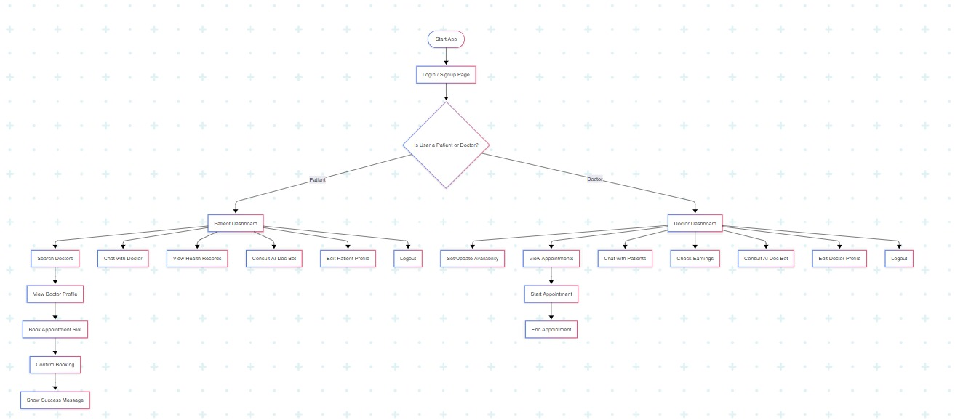

### 1.13.2 Activity Diagram

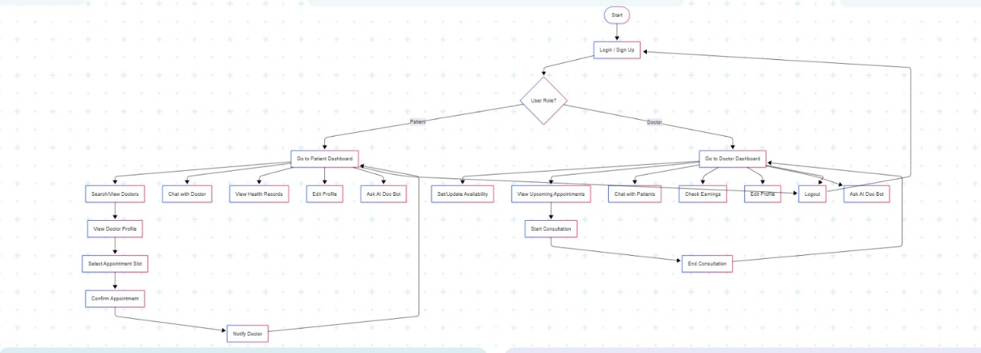

### 1.13.3 Data Flow Diagram

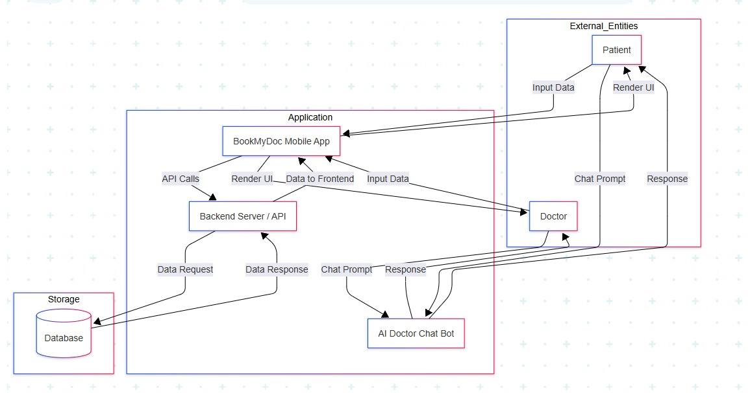

### 1.13.4 Use Case Diagram:

